**University of South Australia**

**UniSA STEM**

**INFT 1031: System Requirements Studio**

**DECLARATION OF CONTRIBUTION**

**Team No: 30174-9**

The following is a declaration of your individual contributions towards this group assessment. If any contribution does not meet the assessment requirements, the course coordinator may adjust individual marks up or down, depending on the level of contribution made.

**Team Member 1 Name:** Michael Harfouch

I contributed _____________ words towards this assessment.

I worked on the following sections/questions (select whichever is appropriate).

Gannt Chart, Team Documents, Mind Map, Stakeholders, User Stories, Gathering Requirements, Formal Requirements Identification, Use Cases

**Team Member 2 Name:** Man Po Zhong

I contributed _____________ words towards this assessment.

I worked on the following sections/questions (select whichever is appropriate).

PROBLEM STATEMENT, STAKEHOLDERS, USER STORIES, Sample Interview Questions, Formal Requirements Identifications, USE CASE MODELLING

**Team Member 3 Name:** Alex Pearson

I contributed _____________ words towards this assessment.

I worked on the following sections/questions (select whichever is appropriate).

MindMap, Function & Non Functional Requirements, Use Cases, Use Case Modelling, Use Case Diagrams, Activity Diagram, Domain Model Diagram

**Team Member 4 Name:** An Truong

I contributed _____________ words towards this assessment.

I worked on the following sections/questions (select whichever is appropriate).

Team Charter, Mind Map, Stakeholders Identifications, User Stories, Gathering Requirements, Formal Requirements Identifications, Interview Questions

**Team Member 5 Name:** Andrew Carter

I contributed _____________ words towards this assessment.

I worked on the following sections/questions (select whichever is appropriate).

Stakeholders, User Stories, Gathering Requirements, Formal Requirements Identification, Use Cases, Use Case Modelling, Domain modelling.

**Textbooks R Us**

Study Period 3, 2021

Prepared by

Michael, An, Po, Alex and Andrew

**Table of Contents**

[1. Gantt Chart 4](https://auc-word-edit.officeapps.live.com/we/wordeditorframe.aspx?new=1&ui=en%2DUS&rs=en%2DUS&wdenableroaming=1&mscc=1&wdodb=1&hid=F9CDC49F-5099-B000-FF5A-9E3AD646618B&wopisrc=https%3A%2F%2Fmymailunisaedu-my.sharepoint.com%2Fpersonal%2Ftruan004_mymail_unisa_edu_au%2F_vti_bin%2Fwopi.ashx%2Ffiles%2F9ba6a0acde904ac7bf6cf77b2e362edb&wdorigin=DocLib&wdhostclicktime=1620187462968&jsapi=1&jsapiver=v1&newsession=1&corrid=cfd9198a-a4b2-4065-8817-e85eec1d429e&usid=cfd9198a-a4b2-4065-8817-e85eec1d429e&sftc=1&mtf=1&wdredirectionreason=Unified_SingleFlush&rct=Medium&ctp=LeastProtected#_Toc70536511)

[2. TEAM DOCUMENTS 4](https://auc-word-edit.officeapps.live.com/we/wordeditorframe.aspx?new=1&ui=en%2DUS&rs=en%2DUS&wdenableroaming=1&mscc=1&wdodb=1&hid=F9CDC49F-5099-B000-FF5A-9E3AD646618B&wopisrc=https%3A%2F%2Fmymailunisaedu-my.sharepoint.com%2Fpersonal%2Ftruan004_mymail_unisa_edu_au%2F_vti_bin%2Fwopi.ashx%2Ffiles%2F9ba6a0acde904ac7bf6cf77b2e362edb&wdorigin=DocLib&wdhostclicktime=1620187462968&jsapi=1&jsapiver=v1&newsession=1&corrid=cfd9198a-a4b2-4065-8817-e85eec1d429e&usid=cfd9198a-a4b2-4065-8817-e85eec1d429e&sftc=1&mtf=1&wdredirectionreason=Unified_SingleFlush&rct=Medium&ctp=LeastProtected#_Toc70536512)

[a. Team Communication Plan 4](https://auc-word-edit.officeapps.live.com/we/wordeditorframe.aspx?new=1&ui=en%2DUS&rs=en%2DUS&wdenableroaming=1&mscc=1&wdodb=1&hid=F9CDC49F-5099-B000-FF5A-9E3AD646618B&wopisrc=https%3A%2F%2Fmymailunisaedu-my.sharepoint.com%2Fpersonal%2Ftruan004_mymail_unisa_edu_au%2F_vti_bin%2Fwopi.ashx%2Ffiles%2F9ba6a0acde904ac7bf6cf77b2e362edb&wdorigin=DocLib&wdhostclicktime=1620187462968&jsapi=1&jsapiver=v1&newsession=1&corrid=cfd9198a-a4b2-4065-8817-e85eec1d429e&usid=cfd9198a-a4b2-4065-8817-e85eec1d429e&sftc=1&mtf=1&wdredirectionreason=Unified_SingleFlush&rct=Medium&ctp=LeastProtected#_Toc70536513)

[b. Team Charter 4](https://auc-word-edit.officeapps.live.com/we/wordeditorframe.aspx?new=1&ui=en%2DUS&rs=en%2DUS&wdenableroaming=1&mscc=1&wdodb=1&hid=F9CDC49F-5099-B000-FF5A-9E3AD646618B&wopisrc=https%3A%2F%2Fmymailunisaedu-my.sharepoint.com%2Fpersonal%2Ftruan004_mymail_unisa_edu_au%2F_vti_bin%2Fwopi.ashx%2Ffiles%2F9ba6a0acde904ac7bf6cf77b2e362edb&wdorigin=DocLib&wdhostclicktime=1620187462968&jsapi=1&jsapiver=v1&newsession=1&corrid=cfd9198a-a4b2-4065-8817-e85eec1d429e&usid=cfd9198a-a4b2-4065-8817-e85eec1d429e&sftc=1&mtf=1&wdredirectionreason=Unified_SingleFlush&rct=Medium&ctp=LeastProtected#_Toc70536514)

[c. Project Team Health Monitor 4](https://auc-word-edit.officeapps.live.com/we/wordeditorframe.aspx?new=1&ui=en%2DUS&rs=en%2DUS&wdenableroaming=1&mscc=1&wdodb=1&hid=F9CDC49F-5099-B000-FF5A-9E3AD646618B&wopisrc=https%3A%2F%2Fmymailunisaedu-my.sharepoint.com%2Fpersonal%2Ftruan004_mymail_unisa_edu_au%2F_vti_bin%2Fwopi.ashx%2Ffiles%2F9ba6a0acde904ac7bf6cf77b2e362edb&wdorigin=DocLib&wdhostclicktime=1620187462968&jsapi=1&jsapiver=v1&newsession=1&corrid=cfd9198a-a4b2-4065-8817-e85eec1d429e&usid=cfd9198a-a4b2-4065-8817-e85eec1d429e&sftc=1&mtf=1&wdredirectionreason=Unified_SingleFlush&rct=Medium&ctp=LeastProtected#_Toc70536515)

[d. Retrospective 4](https://auc-word-edit.officeapps.live.com/we/wordeditorframe.aspx?new=1&ui=en%2DUS&rs=en%2DUS&wdenableroaming=1&mscc=1&wdodb=1&hid=F9CDC49F-5099-B000-FF5A-9E3AD646618B&wopisrc=https%3A%2F%2Fmymailunisaedu-my.sharepoint.com%2Fpersonal%2Ftruan004_mymail_unisa_edu_au%2F_vti_bin%2Fwopi.ashx%2Ffiles%2F9ba6a0acde904ac7bf6cf77b2e362edb&wdorigin=DocLib&wdhostclicktime=1620187462968&jsapi=1&jsapiver=v1&newsession=1&corrid=cfd9198a-a4b2-4065-8817-e85eec1d429e&usid=cfd9198a-a4b2-4065-8817-e85eec1d429e&sftc=1&mtf=1&wdredirectionreason=Unified_SingleFlush&rct=Medium&ctp=LeastProtected#_Toc70536516)

[3. Mind Map 4](https://auc-word-edit.officeapps.live.com/we/wordeditorframe.aspx?new=1&ui=en%2DUS&rs=en%2DUS&wdenableroaming=1&mscc=1&wdodb=1&hid=F9CDC49F-5099-B000-FF5A-9E3AD646618B&wopisrc=https%3A%2F%2Fmymailunisaedu-my.sharepoint.com%2Fpersonal%2Ftruan004_mymail_unisa_edu_au%2F_vti_bin%2Fwopi.ashx%2Ffiles%2F9ba6a0acde904ac7bf6cf77b2e362edb&wdorigin=DocLib&wdhostclicktime=1620187462968&jsapi=1&jsapiver=v1&newsession=1&corrid=cfd9198a-a4b2-4065-8817-e85eec1d429e&usid=cfd9198a-a4b2-4065-8817-e85eec1d429e&sftc=1&mtf=1&wdredirectionreason=Unified_SingleFlush&rct=Medium&ctp=LeastProtected#_Toc70536517)

[4. PROBLEM STATEMENT 4](https://auc-word-edit.officeapps.live.com/we/wordeditorframe.aspx?new=1&ui=en%2DUS&rs=en%2DUS&wdenableroaming=1&mscc=1&wdodb=1&hid=F9CDC49F-5099-B000-FF5A-9E3AD646618B&wopisrc=https%3A%2F%2Fmymailunisaedu-my.sharepoint.com%2Fpersonal%2Ftruan004_mymail_unisa_edu_au%2F_vti_bin%2Fwopi.ashx%2Ffiles%2F9ba6a0acde904ac7bf6cf77b2e362edb&wdorigin=DocLib&wdhostclicktime=1620187462968&jsapi=1&jsapiver=v1&newsession=1&corrid=cfd9198a-a4b2-4065-8817-e85eec1d429e&usid=cfd9198a-a4b2-4065-8817-e85eec1d429e&sftc=1&mtf=1&wdredirectionreason=Unified_SingleFlush&rct=Medium&ctp=LeastProtected#_Toc70536518)

[5. STAKEHOLDERS 4](https://auc-word-edit.officeapps.live.com/we/wordeditorframe.aspx?new=1&ui=en%2DUS&rs=en%2DUS&wdenableroaming=1&mscc=1&wdodb=1&hid=F9CDC49F-5099-B000-FF5A-9E3AD646618B&wopisrc=https%3A%2F%2Fmymailunisaedu-my.sharepoint.com%2Fpersonal%2Ftruan004_mymail_unisa_edu_au%2F_vti_bin%2Fwopi.ashx%2Ffiles%2F9ba6a0acde904ac7bf6cf77b2e362edb&wdorigin=DocLib&wdhostclicktime=1620187462968&jsapi=1&jsapiver=v1&newsession=1&corrid=cfd9198a-a4b2-4065-8817-e85eec1d429e&usid=cfd9198a-a4b2-4065-8817-e85eec1d429e&sftc=1&mtf=1&wdredirectionreason=Unified_SingleFlush&rct=Medium&ctp=LeastProtected#_Toc70536519)

[6. USER STORIES 4](https://auc-word-edit.officeapps.live.com/we/wordeditorframe.aspx?new=1&ui=en%2DUS&rs=en%2DUS&wdenableroaming=1&mscc=1&wdodb=1&hid=F9CDC49F-5099-B000-FF5A-9E3AD646618B&wopisrc=https%3A%2F%2Fmymailunisaedu-my.sharepoint.com%2Fpersonal%2Ftruan004_mymail_unisa_edu_au%2F_vti_bin%2Fwopi.ashx%2Ffiles%2F9ba6a0acde904ac7bf6cf77b2e362edb&wdorigin=DocLib&wdhostclicktime=1620187462968&jsapi=1&jsapiver=v1&newsession=1&corrid=cfd9198a-a4b2-4065-8817-e85eec1d429e&usid=cfd9198a-a4b2-4065-8817-e85eec1d429e&sftc=1&mtf=1&wdredirectionreason=Unified_SingleFlush&rct=Medium&ctp=LeastProtected#_Toc70536520)

[7. GATHERING REQUIREMENTS 5](https://auc-word-edit.officeapps.live.com/we/wordeditorframe.aspx?new=1&ui=en%2DUS&rs=en%2DUS&wdenableroaming=1&mscc=1&wdodb=1&hid=F9CDC49F-5099-B000-FF5A-9E3AD646618B&wopisrc=https%3A%2F%2Fmymailunisaedu-my.sharepoint.com%2Fpersonal%2Ftruan004_mymail_unisa_edu_au%2F_vti_bin%2Fwopi.ashx%2Ffiles%2F9ba6a0acde904ac7bf6cf77b2e362edb&wdorigin=DocLib&wdhostclicktime=1620187462968&jsapi=1&jsapiver=v1&newsession=1&corrid=cfd9198a-a4b2-4065-8817-e85eec1d429e&usid=cfd9198a-a4b2-4065-8817-e85eec1d429e&sftc=1&mtf=1&wdredirectionreason=Unified_SingleFlush&rct=Medium&ctp=LeastProtected#_Toc70536521)

[a. Techniques 5](https://auc-word-edit.officeapps.live.com/we/wordeditorframe.aspx?new=1&ui=en%2DUS&rs=en%2DUS&wdenableroaming=1&mscc=1&wdodb=1&hid=F9CDC49F-5099-B000-FF5A-9E3AD646618B&wopisrc=https%3A%2F%2Fmymailunisaedu-my.sharepoint.com%2Fpersonal%2Ftruan004_mymail_unisa_edu_au%2F_vti_bin%2Fwopi.ashx%2Ffiles%2F9ba6a0acde904ac7bf6cf77b2e362edb&wdorigin=DocLib&wdhostclicktime=1620187462968&jsapi=1&jsapiver=v1&newsession=1&corrid=cfd9198a-a4b2-4065-8817-e85eec1d429e&usid=cfd9198a-a4b2-4065-8817-e85eec1d429e&sftc=1&mtf=1&wdredirectionreason=Unified_SingleFlush&rct=Medium&ctp=LeastProtected#_Toc70536522)

[b. Who to Interview 5](https://auc-word-edit.officeapps.live.com/we/wordeditorframe.aspx?new=1&ui=en%2DUS&rs=en%2DUS&wdenableroaming=1&mscc=1&wdodb=1&hid=F9CDC49F-5099-B000-FF5A-9E3AD646618B&wopisrc=https%3A%2F%2Fmymailunisaedu-my.sharepoint.com%2Fpersonal%2Ftruan004_mymail_unisa_edu_au%2F_vti_bin%2Fwopi.ashx%2Ffiles%2F9ba6a0acde904ac7bf6cf77b2e362edb&wdorigin=DocLib&wdhostclicktime=1620187462968&jsapi=1&jsapiver=v1&newsession=1&corrid=cfd9198a-a4b2-4065-8817-e85eec1d429e&usid=cfd9198a-a4b2-4065-8817-e85eec1d429e&sftc=1&mtf=1&wdredirectionreason=Unified_SingleFlush&rct=Medium&ctp=LeastProtected#_Toc70536523)

[c. Sample Interview Questions 5](https://auc-word-edit.officeapps.live.com/we/wordeditorframe.aspx?new=1&ui=en%2DUS&rs=en%2DUS&wdenableroaming=1&mscc=1&wdodb=1&hid=F9CDC49F-5099-B000-FF5A-9E3AD646618B&wopisrc=https%3A%2F%2Fmymailunisaedu-my.sharepoint.com%2Fpersonal%2Ftruan004_mymail_unisa_edu_au%2F_vti_bin%2Fwopi.ashx%2Ffiles%2F9ba6a0acde904ac7bf6cf77b2e362edb&wdorigin=DocLib&wdhostclicktime=1620187462968&jsapi=1&jsapiver=v1&newsession=1&corrid=cfd9198a-a4b2-4065-8817-e85eec1d429e&usid=cfd9198a-a4b2-4065-8817-e85eec1d429e&sftc=1&mtf=1&wdredirectionreason=Unified_SingleFlush&rct=Medium&ctp=LeastProtected#_Toc70536524)

[8. FORMAL REQUIREMENTS IDENTIFICATION 5](https://auc-word-edit.officeapps.live.com/we/wordeditorframe.aspx?new=1&ui=en%2DUS&rs=en%2DUS&wdenableroaming=1&mscc=1&wdodb=1&hid=F9CDC49F-5099-B000-FF5A-9E3AD646618B&wopisrc=https%3A%2F%2Fmymailunisaedu-my.sharepoint.com%2Fpersonal%2Ftruan004_mymail_unisa_edu_au%2F_vti_bin%2Fwopi.ashx%2Ffiles%2F9ba6a0acde904ac7bf6cf77b2e362edb&wdorigin=DocLib&wdhostclicktime=1620187462968&jsapi=1&jsapiver=v1&newsession=1&corrid=cfd9198a-a4b2-4065-8817-e85eec1d429e&usid=cfd9198a-a4b2-4065-8817-e85eec1d429e&sftc=1&mtf=1&wdredirectionreason=Unified_SingleFlush&rct=Medium&ctp=LeastProtected#_Toc70536525)

[a. Functional Requirements 5](https://auc-word-edit.officeapps.live.com/we/wordeditorframe.aspx?new=1&ui=en%2DUS&rs=en%2DUS&wdenableroaming=1&mscc=1&wdodb=1&hid=F9CDC49F-5099-B000-FF5A-9E3AD646618B&wopisrc=https%3A%2F%2Fmymailunisaedu-my.sharepoint.com%2Fpersonal%2Ftruan004_mymail_unisa_edu_au%2F_vti_bin%2Fwopi.ashx%2Ffiles%2F9ba6a0acde904ac7bf6cf77b2e362edb&wdorigin=DocLib&wdhostclicktime=1620187462968&jsapi=1&jsapiver=v1&newsession=1&corrid=cfd9198a-a4b2-4065-8817-e85eec1d429e&usid=cfd9198a-a4b2-4065-8817-e85eec1d429e&sftc=1&mtf=1&wdredirectionreason=Unified_SingleFlush&rct=Medium&ctp=LeastProtected#_Toc70536526)

[b. Non-Functional Requirements 5](https://auc-word-edit.officeapps.live.com/we/wordeditorframe.aspx?new=1&ui=en%2DUS&rs=en%2DUS&wdenableroaming=1&mscc=1&wdodb=1&hid=F9CDC49F-5099-B000-FF5A-9E3AD646618B&wopisrc=https%3A%2F%2Fmymailunisaedu-my.sharepoint.com%2Fpersonal%2Ftruan004_mymail_unisa_edu_au%2F_vti_bin%2Fwopi.ashx%2Ffiles%2F9ba6a0acde904ac7bf6cf77b2e362edb&wdorigin=DocLib&wdhostclicktime=1620187462968&jsapi=1&jsapiver=v1&newsession=1&corrid=cfd9198a-a4b2-4065-8817-e85eec1d429e&usid=cfd9198a-a4b2-4065-8817-e85eec1d429e&sftc=1&mtf=1&wdredirectionreason=Unified_SingleFlush&rct=Medium&ctp=LeastProtected#_Toc70536527)

[c. Prioritisation of Requirements 6](https://auc-word-edit.officeapps.live.com/we/wordeditorframe.aspx?new=1&ui=en%2DUS&rs=en%2DUS&wdenableroaming=1&mscc=1&wdodb=1&hid=F9CDC49F-5099-B000-FF5A-9E3AD646618B&wopisrc=https%3A%2F%2Fmymailunisaedu-my.sharepoint.com%2Fpersonal%2Ftruan004_mymail_unisa_edu_au%2F_vti_bin%2Fwopi.ashx%2Ffiles%2F9ba6a0acde904ac7bf6cf77b2e362edb&wdorigin=DocLib&wdhostclicktime=1620187462968&jsapi=1&jsapiver=v1&newsession=1&corrid=cfd9198a-a4b2-4065-8817-e85eec1d429e&usid=cfd9198a-a4b2-4065-8817-e85eec1d429e&sftc=1&mtf=1&wdredirectionreason=Unified_SingleFlush&rct=Medium&ctp=LeastProtected#_Toc70536528)

[9. USE CASES 6](https://auc-word-edit.officeapps.live.com/we/wordeditorframe.aspx?new=1&ui=en%2DUS&rs=en%2DUS&wdenableroaming=1&mscc=1&wdodb=1&hid=F9CDC49F-5099-B000-FF5A-9E3AD646618B&wopisrc=https%3A%2F%2Fmymailunisaedu-my.sharepoint.com%2Fpersonal%2Ftruan004_mymail_unisa_edu_au%2F_vti_bin%2Fwopi.ashx%2Ffiles%2F9ba6a0acde904ac7bf6cf77b2e362edb&wdorigin=DocLib&wdhostclicktime=1620187462968&jsapi=1&jsapiver=v1&newsession=1&corrid=cfd9198a-a4b2-4065-8817-e85eec1d429e&usid=cfd9198a-a4b2-4065-8817-e85eec1d429e&sftc=1&mtf=1&wdredirectionreason=Unified_SingleFlush&rct=Medium&ctp=LeastProtected#_Toc70536529)

[a. Actors 6](https://auc-word-edit.officeapps.live.com/we/wordeditorframe.aspx?new=1&ui=en%2DUS&rs=en%2DUS&wdenableroaming=1&mscc=1&wdodb=1&hid=F9CDC49F-5099-B000-FF5A-9E3AD646618B&wopisrc=https%3A%2F%2Fmymailunisaedu-my.sharepoint.com%2Fpersonal%2Ftruan004_mymail_unisa_edu_au%2F_vti_bin%2Fwopi.ashx%2Ffiles%2F9ba6a0acde904ac7bf6cf77b2e362edb&wdorigin=DocLib&wdhostclicktime=1620187462968&jsapi=1&jsapiver=v1&newsession=1&corrid=cfd9198a-a4b2-4065-8817-e85eec1d429e&usid=cfd9198a-a4b2-4065-8817-e85eec1d429e&sftc=1&mtf=1&wdredirectionreason=Unified_SingleFlush&rct=Medium&ctp=LeastProtected#_Toc70536530)

[b. Use Cases 6](https://auc-word-edit.officeapps.live.com/we/wordeditorframe.aspx?new=1&ui=en%2DUS&rs=en%2DUS&wdenableroaming=1&mscc=1&wdodb=1&hid=F9CDC49F-5099-B000-FF5A-9E3AD646618B&wopisrc=https%3A%2F%2Fmymailunisaedu-my.sharepoint.com%2Fpersonal%2Ftruan004_mymail_unisa_edu_au%2F_vti_bin%2Fwopi.ashx%2Ffiles%2F9ba6a0acde904ac7bf6cf77b2e362edb&wdorigin=DocLib&wdhostclicktime=1620187462968&jsapi=1&jsapiver=v1&newsession=1&corrid=cfd9198a-a4b2-4065-8817-e85eec1d429e&usid=cfd9198a-a4b2-4065-8817-e85eec1d429e&sftc=1&mtf=1&wdredirectionreason=Unified_SingleFlush&rct=Medium&ctp=LeastProtected#_Toc70536531)

[c. Use Case Diagram 6](https://auc-word-edit.officeapps.live.com/we/wordeditorframe.aspx?new=1&ui=en%2DUS&rs=en%2DUS&wdenableroaming=1&mscc=1&wdodb=1&hid=F9CDC49F-5099-B000-FF5A-9E3AD646618B&wopisrc=https%3A%2F%2Fmymailunisaedu-my.sharepoint.com%2Fpersonal%2Ftruan004_mymail_unisa_edu_au%2F_vti_bin%2Fwopi.ashx%2Ffiles%2F9ba6a0acde904ac7bf6cf77b2e362edb&wdorigin=DocLib&wdhostclicktime=1620187462968&jsapi=1&jsapiver=v1&newsession=1&corrid=cfd9198a-a4b2-4065-8817-e85eec1d429e&usid=cfd9198a-a4b2-4065-8817-e85eec1d429e&sftc=1&mtf=1&wdredirectionreason=Unified_SingleFlush&rct=Medium&ctp=LeastProtected#_Toc70536532)

[10. USE CASE MODELLING 6](https://auc-word-edit.officeapps.live.com/we/wordeditorframe.aspx?new=1&ui=en%2DUS&rs=en%2DUS&wdenableroaming=1&mscc=1&wdodb=1&hid=F9CDC49F-5099-B000-FF5A-9E3AD646618B&wopisrc=https%3A%2F%2Fmymailunisaedu-my.sharepoint.com%2Fpersonal%2Ftruan004_mymail_unisa_edu_au%2F_vti_bin%2Fwopi.ashx%2Ffiles%2F9ba6a0acde904ac7bf6cf77b2e362edb&wdorigin=DocLib&wdhostclicktime=1620187462968&jsapi=1&jsapiver=v1&newsession=1&corrid=cfd9198a-a4b2-4065-8817-e85eec1d429e&usid=cfd9198a-a4b2-4065-8817-e85eec1d429e&sftc=1&mtf=1&wdredirectionreason=Unified_SingleFlush&rct=Medium&ctp=LeastProtected#_Toc70536533)

[a. Fully Developed Use Case Description 6](https://auc-word-edit.officeapps.live.com/we/wordeditorframe.aspx?new=1&ui=en%2DUS&rs=en%2DUS&wdenableroaming=1&mscc=1&wdodb=1&hid=F9CDC49F-5099-B000-FF5A-9E3AD646618B&wopisrc=https%3A%2F%2Fmymailunisaedu-my.sharepoint.com%2Fpersonal%2Ftruan004_mymail_unisa_edu_au%2F_vti_bin%2Fwopi.ashx%2Ffiles%2F9ba6a0acde904ac7bf6cf77b2e362edb&wdorigin=DocLib&wdhostclicktime=1620187462968&jsapi=1&jsapiver=v1&newsession=1&corrid=cfd9198a-a4b2-4065-8817-e85eec1d429e&usid=cfd9198a-a4b2-4065-8817-e85eec1d429e&sftc=1&mtf=1&wdredirectionreason=Unified_SingleFlush&rct=Medium&ctp=LeastProtected#_Toc70536534)

[b. Activity Diagram 7](https://auc-word-edit.officeapps.live.com/we/wordeditorframe.aspx?new=1&ui=en%2DUS&rs=en%2DUS&wdenableroaming=1&mscc=1&wdodb=1&hid=F9CDC49F-5099-B000-FF5A-9E3AD646618B&wopisrc=https%3A%2F%2Fmymailunisaedu-my.sharepoint.com%2Fpersonal%2Ftruan004_mymail_unisa_edu_au%2F_vti_bin%2Fwopi.ashx%2Ffiles%2F9ba6a0acde904ac7bf6cf77b2e362edb&wdorigin=DocLib&wdhostclicktime=1620187462968&jsapi=1&jsapiver=v1&newsession=1&corrid=cfd9198a-a4b2-4065-8817-e85eec1d429e&usid=cfd9198a-a4b2-4065-8817-e85eec1d429e&sftc=1&mtf=1&wdredirectionreason=Unified_SingleFlush&rct=Medium&ctp=LeastProtected#_Toc70536535)

[11. DOMAIN MODELLING 7](https://auc-word-edit.officeapps.live.com/we/wordeditorframe.aspx?new=1&ui=en%2DUS&rs=en%2DUS&wdenableroaming=1&mscc=1&wdodb=1&hid=F9CDC49F-5099-B000-FF5A-9E3AD646618B&wopisrc=https%3A%2F%2Fmymailunisaedu-my.sharepoint.com%2Fpersonal%2Ftruan004_mymail_unisa_edu_au%2F_vti_bin%2Fwopi.ashx%2Ffiles%2F9ba6a0acde904ac7bf6cf77b2e362edb&wdorigin=DocLib&wdhostclicktime=1620187462968&jsapi=1&jsapiver=v1&newsession=1&corrid=cfd9198a-a4b2-4065-8817-e85eec1d429e&usid=cfd9198a-a4b2-4065-8817-e85eec1d429e&sftc=1&mtf=1&wdredirectionreason=Unified_SingleFlush&rct=Medium&ctp=LeastProtected#_Toc70536536)

[a. Domain Classes and Attributes 7](https://auc-word-edit.officeapps.live.com/we/wordeditorframe.aspx?new=1&ui=en%2DUS&rs=en%2DUS&wdenableroaming=1&mscc=1&wdodb=1&hid=F9CDC49F-5099-B000-FF5A-9E3AD646618B&wopisrc=https%3A%2F%2Fmymailunisaedu-my.sharepoint.com%2Fpersonal%2Ftruan004_mymail_unisa_edu_au%2F_vti_bin%2Fwopi.ashx%2Ffiles%2F9ba6a0acde904ac7bf6cf77b2e362edb&wdorigin=DocLib&wdhostclicktime=1620187462968&jsapi=1&jsapiver=v1&newsession=1&corrid=cfd9198a-a4b2-4065-8817-e85eec1d429e&usid=cfd9198a-a4b2-4065-8817-e85eec1d429e&sftc=1&mtf=1&wdredirectionreason=Unified_SingleFlush&rct=Medium&ctp=LeastProtected#_Toc70536537)

[b. Domain Model Class Diagram 7](https://auc-word-edit.officeapps.live.com/we/wordeditorframe.aspx?new=1&ui=en%2DUS&rs=en%2DUS&wdenableroaming=1&mscc=1&wdodb=1&hid=F9CDC49F-5099-B000-FF5A-9E3AD646618B&wopisrc=https%3A%2F%2Fmymailunisaedu-my.sharepoint.com%2Fpersonal%2Ftruan004_mymail_unisa_edu_au%2F_vti_bin%2Fwopi.ashx%2Ffiles%2F9ba6a0acde904ac7bf6cf77b2e362edb&wdorigin=DocLib&wdhostclicktime=1620187462968&jsapi=1&jsapiver=v1&newsession=1&corrid=cfd9198a-a4b2-4065-8817-e85eec1d429e&usid=cfd9198a-a4b2-4065-8817-e85eec1d429e&sftc=1&mtf=1&wdredirectionreason=Unified_SingleFlush&rct=Medium&ctp=LeastProtected#_Toc70536538)

[c. Associations 7](https://auc-word-edit.officeapps.live.com/we/wordeditorframe.aspx?new=1&ui=en%2DUS&rs=en%2DUS&wdenableroaming=1&mscc=1&wdodb=1&hid=F9CDC49F-5099-B000-FF5A-9E3AD646618B&wopisrc=https%3A%2F%2Fmymailunisaedu-my.sharepoint.com%2Fpersonal%2Ftruan004_mymail_unisa_edu_au%2F_vti_bin%2Fwopi.ashx%2Ffiles%2F9ba6a0acde904ac7bf6cf77b2e362edb&wdorigin=DocLib&wdhostclicktime=1620187462968&jsapi=1&jsapiver=v1&newsession=1&corrid=cfd9198a-a4b2-4065-8817-e85eec1d429e&usid=cfd9198a-a4b2-4065-8817-e85eec1d429e&sftc=1&mtf=1&wdredirectionreason=Unified_SingleFlush&rct=Medium&ctp=LeastProtected#_Toc70536539)

To update the table of contents with the correct headings in your document – click within the table of contents and then press F9. Headings within the document use the “Heading” style. Normal text uses the “Normal” style. <REMEMBER TO DELETE THIS TEXT>

# 1. Gantt Chart

|  |  |  |  |  |  |  |  |  |  |  |  |  |  |
| --- | --- | --- | --- | --- | --- | --- | --- | --- | --- | --- | --- | --- | --- |
|  | 5/5/21 | 6/5/21 | 7/5/21 | 8/5/21 | 9/5/21 | 10/5/21 | 11/5/21 | 12/5/21 | 13/5/21 | 14/5/21 | 15/5/21 | 16/5/21 | 17/5/21 |
| S1. Gantt Chart |  |  |  |  |  |  |  |  |  |  |  |  |  |
| S2. Team Documents |  |  |  |  |  |  |  |  |  |  |  |  |  |
| S3. Mind Map |  |  |  |  |  |  |  |  |  |  |  |  |  |
| S4. Problem Statements |  |  |  |  |  |  |  |  |  |  |  |  |  |
| S5. Stake Holders |  |  |  |  |  |  |  |  |  |  |  |  |  |
| S6. User Stories |  |  |  |  |  |  |  |  |  |  |  |  |  |
| S7. Gathering Requirements |  |  |  |  |  |  |  |  |  |  |  |  |  |
| S8. Formal Requirements Identification |  |  |  |  |  |  |  |  |  |  |  |  |  |
| S9. Use Cases |  |  |  |  |  |  |  |  |  |  |  |  |  |
| S10. Use Case Modelling |  |  |  |  |  |  |  |  |  |  |  |  |  |
| S11. Domain Modelling |  |  |  |  |  |  |  |  |  |  |  |  |  |
| SXX. Assignment Submission |  |  |  |  |  |  |  |  |  |  |  |  |  |

# 2. TEAM DOCUMENTS

### a. Team Communication Plan

Discord will be used for communication and Trello will be used for organization. The One Drive will be used for editing and creating documents jointly.

### b. Team Charter

**Team Purpose**

Complete the assignment and its objectives to a satisfactory level.

**Team Members**

1. Michael Harfouch
2. Alex Pearson
3. An Truong
4. Andrew Carter
5. MAN PO ZHONG

**Duration and Time Commitment**

1 ½ weeks duration. Minimum 5 hours commitment per week.

**Deliverables**

1x Completed Assignment

**Answer the following questions to help your team get off to a positive start.**

1. What will you do if someone....?

* Can’t make it to a meeting.

Put the summary of the meeting on the Trello board (in the communication column) for the absent individuals to be able to recap.

* Doesn’t agree with the way things are being done.

Raise issues to the group for discussion.

* Doesn’t understand what to do.

Ask in the Trello board under the communications column – if necessary, we can have a team meeting to follow up.

* Feels they’re doing more than the others.

Have a meeting or alternative negotiation to rearrange the tasks equally

* Feels everything is running behind schedule.

Have a meeting or alternative negotiation to gather recent working process of the team, therefore, together figuring out the appropriate solutions for each member’s struggling tasks.

* Doesn’t say much at meetings.

Be open-minded and encourage that member to contribute into the teamwork, then allocate appropriate tasks for them if necessary.

1. How will you...?

* Allocate tasks?
  + Have a meeting and together build up the structure of the work, brainstorming, get the core plan ideas and list a collection of essential tasks.
  + Identify each member Streight and Weakness to allocate them into the most suitable tasks and receive the most effective result.
  + Manage team member’s deadlines and time of contribution.
* Prioritise?
* Identify the task based on its importance and urgency.
* Follow the bellow rules which are based on the book “The 7 Habits of Highly Effective People”:
* Urgent and important: These tasks should be done first.
* Important but not urgent: Block off time on your calendar to get this done, without interruption.
* Urgent but unimportant: Delegate. Delegate. Delegate.
* Neither urgent or important: Remove from your to-do list.
* Ensure everyone gets their work done?
  + Have a record that demonstrate a checklist of upcoming tasks, finished tasks and on-going tasks.
  + Use share documents platform to work on the task that every member can catch up with the process of the work.
  + Leave feedback, comment on each task, and negotiate that task if necessary.

* Stay in contact with each other?

Use communication platform to negotiate work:

* + Trello: to-do list tasks, main project process
  + Discord or Zoom: verbal communication and virtual meeting.
  + OneDrive doc: shared documents
* Run your meetings?
  + In person should be better but inconvenient.
  + Meeting runs on Discord or Zoom (depend on which one is more convenient to every member)
  + Having a minute record for each meeting that allows absent member to catch up with the process of that meeting.

1. How often will you meet up together?

* Twice or three times per week (approximate)
* OR just ONCE per week should be enough to summarize the progress of given tasks of every member.

1. What roles should be taken on in the group?

Team Leader and Team Members

1. How will everyone’s progress be kept track of?

* Provide a specific plan including tasks allocation for each member (will be shared during the project to keep up with)
* Have a record that demonstrate a checklist of upcoming tasks, finished tasks and on-going tasks.
* Update the individual progress on the task checklist.

1. What other potential problems do you think the group could have?

* Lose track of tasks.
* Have conflict on discussing about tasks.

### c. Project Team Health Monitor

[tinyurl.com/da2vsk4r](http://tinyurl.com/da2vsk4r)

### d. Retrospective

<Place your retrospective here>.

# 3. Mind Map

<Place your mind map here>.

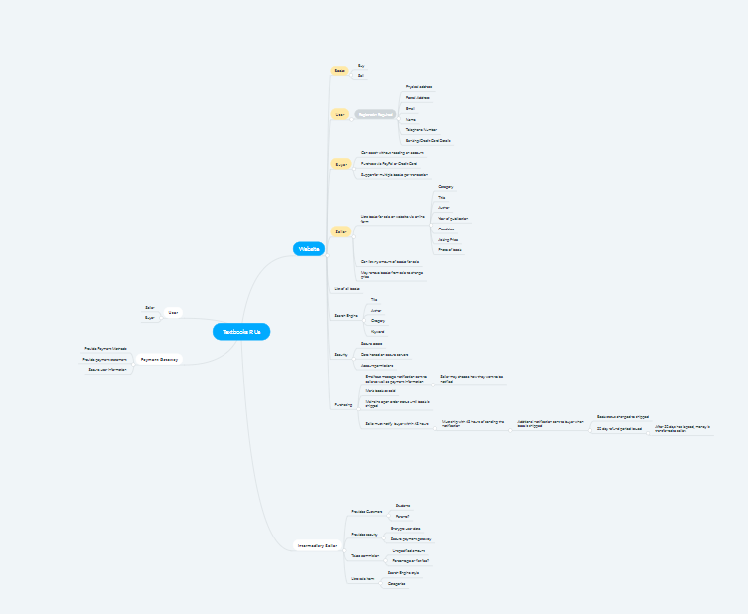

# 4. PROBLEM STATEMENT

Textbooks R Us is a small business that provides a market for university students to buy and sell secondhand books. Textbooks R Us want to change their business model to a e-business model to sell books online in order to expand their business. To make this happen they need a website that features all the trading functions necessary to allow users to buy and sell books such as a login system, a way to search and view books that are for sale, as well a means to purchase books via a payment system.

5. STAKEHOLDERS

Owner – The client.

Investors – Finance the new system.

Accountant – Responsible for the finances of the client.

Competitors – Have a vested interest in the success/failure of the client.

Web developer - Responsible for developing the new website for the client.

Server host – Will host the client’s website.

IT support - Will support the client’s hardware/software requirements and assist users of the system.

PayPal - Processes PayPal payments for the client’s website.

Payment Gateway – credit card payment processing for the client’s website.

Buyer – Creates an account on the website to buy textbooks with.

Seller – Creates an account on the website to sell textbooks with.

Website Admin – Manages the website and is responsible for banning fraudulent users.

|  |  |  |
| --- | --- | --- |
| **Category** | **Degree** | **Stakeholder** |
| **Project stakeholder** |  | Owner  Investors  Accountant  Competitors  Web Developer  Server host  IT support  PayPal  Payment Gateway |
| **System stakeholder** | First degree | Buyer  Seller |
|  | Second degree | Accountant  Owner |
|  | Third degree | IT Support  Web Developer  Website Admin |

# 6. USER STORIES

**User (Buyers and Sellers)**

As a User, I want to have an account so that can sell or buy books.

As a User, I want to choose to be either seller or buyer so that I could sell or buy.

As a User, I want to give the feedback about the system so that I could have a better service.

As a User, I want to receive the receipt so that I can know that I have bought the books successfully.

As a User, I want to secure my personal information so that my privacy is protected.

As a User, I want to access and receive announcement about my books in order so that I can keep track of the process of my order.

As a User, I want to place orders for available books on a website so that I can make orders quickly.

**Seller**

As a Seller, I want to access the policy and term of conditions so that I can know which books are legal and appropriate for selling via the system.

As a Seller, I want to upload the information of the book I would sell so that the buyer can approach it.

As a Seller, I want to choose the payment method so that I can receive the payment from the buyer.

**Buyer**

As a Buyer, I want to search the book by the title, Author or Year so that I can find the book that I search for.

As a Buyer, I want to search the book by theme so that I can find the list of the book with the same theme that I am interested in.

As a Buyer, I want to search the price of the books so that I can buy the appropriate book.

As a Buyer, I want to access the description of the book so that I can know the outline content of the book.

As a Buyer, I want to add the books to the cart so that I can know what books I am tend to buy.

As a Buyer, I want to save the list of books that I am interested so that I can compare them.

As a Buyer, I want to choose the payment method so that I can buy the books.

As a Buyer, I want to give the feedback about the seller so that other buyer can have more recommendation.

As a Buyer, I want to be able to access my orders history so that I can keep track on what I have ordered and what is in process.

As a Buyer, I want to have suggestions of the similar books so that I can find other books that I am interested in.

**Accountant**

As an Accountant, I want to be able to access sales reports so that I can summarize and check for the sale information.

As an Accountant, I want to be able to access all the tools that I can do my job efficiently.

As an Accountant, I want to be able to know how the system works so that I don’t need to have training.

As an Accountant, I want to be able to the payment system so I can know all the employees to make sure that have pay weekly.

**Owner**

As an Owner, I want to be able to access the data of users account so that I can manage the accounts and sale information.

As an Owner, I want more customers to use the system, so that I can make more money.

As an Owner, I want to create a successful business so that I can make a steady income.

# 7. GATHERING REQUIREMENTS

### a. Techniques

In order to gather requirements for the new system for Textbooks R Us, an interview of a first- or second-degree system stakeholder is recommended. Alternatively, a Questionnaire could be provided to a larger sample size of potential users (first-degree system stakeholders) of the new system, which may provide a larger amount of correlative data.

### b. Who to Interview

The requirements gathering interview will be designed for the business owner, as they are the client. The business owner may not necessarily

### c. Sample Interview Questions

|  |  |
| --- | --- |
| 1. How many people do you estimate will use your website on a daily basis? |  |
| 1. Which questions are frequently asked by customers when they are searching for a textbook? |  |
| 1. How often do you imagine your new system will be upgraded? |  |
| 1. Is there going to be a sales policy to ensure the sale of legal books via your system? |  |
| 1. On average, how many orders are *currently* made each month? |  |
| 1. How are orders currently handled? |  |
| 1. What exact security requirements are necessary for your system? |  |
| 1. What is the latest date that you are planning to launch your new system? |  |
| 1. What are the different tiers of access to your system that you will need? (e.g. User level, Admin level, Super-Admin level) |  |
| 1. Are there any specific things you have seen on similar systems which you ***must*** have implemented on your own? |  |

# 8. FORMAL REQUIREMENTS IDENTIFICATION

### a. Functional Requirements

Sign Up/Login

FR1. The system shall provide a form for users to register new accounts.

FR2. The system shall allow users to submit personal details via the registration form.

FR3. The system shall send users a registration confirmation email with log-in details.

FR4. The system shall allow users to update personal details.

FR5. The system shall allow users to login and logout.

FR6. The system shall allow users to recover their account if they forget their password.

Selling

FR8. The system shall provide a ‘Sales Policy’ to ensure non-fraudulent and legal activity.

FR8. The system shall allow users to list books for sale.

FR9. The system shall allow users to set a price for books listed for sale.

FR10. The system shall allow users to specify the condition of books for sale.

FR11. The system shall allow users to upload a photo of a book listed for sale.

FR12. The system shall notify users when a listed book has been sold.

FR13. The system shall allow users to send notifications to buyers when they accept their purchase.

Buying

FR14. The system shall allow users to search for the book by the title, theme, author, price, category,

keyword, course/program, year and edition.

FR15. The system shall display a book description to the user.

FR16. The system shall allow users to add the books to their cart.

FR17. The system shall allow users to access their order history.

FR18. The system shall allow user to compare chosen books.

FR19. The system shall allow users to provide feedback of sellers and their listed books.

FR20. The system shall allow users to report fraudulent or illegal activity from sellers.

Orders

FR21. The system shall display the purchasing policy for both seller and buyer.

FR22. The system shall verify user’s acceptance of the policy.

FR23. The system shall notify users that their books have been ordered.

FR24. The system shall notify users of updates to their orders via email.

FR25. The system shall assign an order number to the users’ order.

Payment

FR28. The system shall allow users to choose a payment method either via internal payment gateway or directly via PayPal.

FR29. The system shall present users with an invoice.

FR30. The system shall allow the user to pay all the items in a cart together.

FR31. The system shall redirect users to their nominated payment gateway.

FR32. The system shall receive payment confirmation from the payment gateway.

FR33 The system shall provide users with a payment receipt.

### b. Non-Functional Requirements

**Usability**

NFR1. The system must provide multiple language options.

NFR2. The system must provide feedback to the user within 200ms.

NFR3. The system must provide website support for both desktop and mobile browsers.

NFR4. The system must provide multiple language options.

**Reliability**

NFR5. The system must have 99% uptime.

NFR6. The system must maintain daily backups of the database.

**Performance**

NFR7. The system must allow a minimum of 100 concurrent users at any one time.

NFR8. The system must load in under 1 second.

**Supportability**

NFR9. The system must be designed with extensible code.

NFR10. The system must allow for future expansion in terms of hardware.

**Design Constraints**

NFR11. The system must display an SSL certificate to provide authentication of ownership to the user and enable an encrypted connection.  
NFR12. The system must encrypt user details using SHA-256 encrypting algorithms.

### c. Prioritization of Requirements

In completing the prioritization of requirements, the Pairwise Comparison method was chosen for both the Functional and Non-Functional Requirements. This comparative method was chosen based on the consensus of the group, as it was perceived that the Pairwise Comparison method fit the best criteria. Due to limitations in the Pairwise Comparison method, some requirements receive equal weighting, however they are displayed in numerical order for clarity.

# 9. USE CASES

### a. Actors

Buyer

Seller

Website Admin

### b. Use Cases

**User**

UC001. Register Account

UC02. Login

UC03. Update Account Details

UC04. Recover Account

**User (Buyer)**

UC05. Search

UC06. Add to cart

UC07. Checkout

UC08. Update payment method

UC09. Confirm payment

**User (Seller)**

UC10. List book

UC11. Set condition

UC12. Set price

UC13. Receive sale notification

UC14. Confirm shipping status

UC15. Send shipping notification

UC16. Remove listing

**Employee (Accountant & Owner)**

UC17. Access financial records

UC18. View invoices

UC19. View sale statistics

**Employee (Website Admin & Owner)**

UC20. Create database backups

UC21. Suspend user accounts

**Payment Gateway**

UC22. Send payment receipt to users

UC23. Display payment statement

**PayPal**

UC24. Direct user to PayPal system

UC25. Display payment confirmation

### c. Use Case Diagram

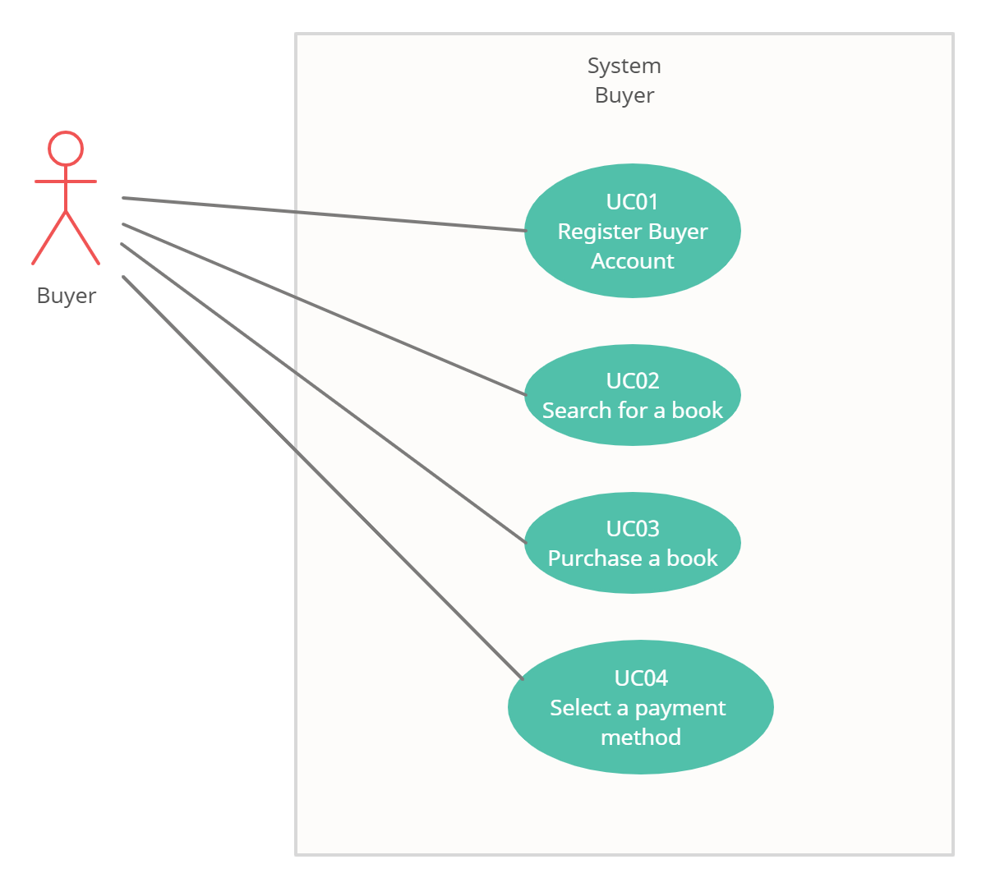

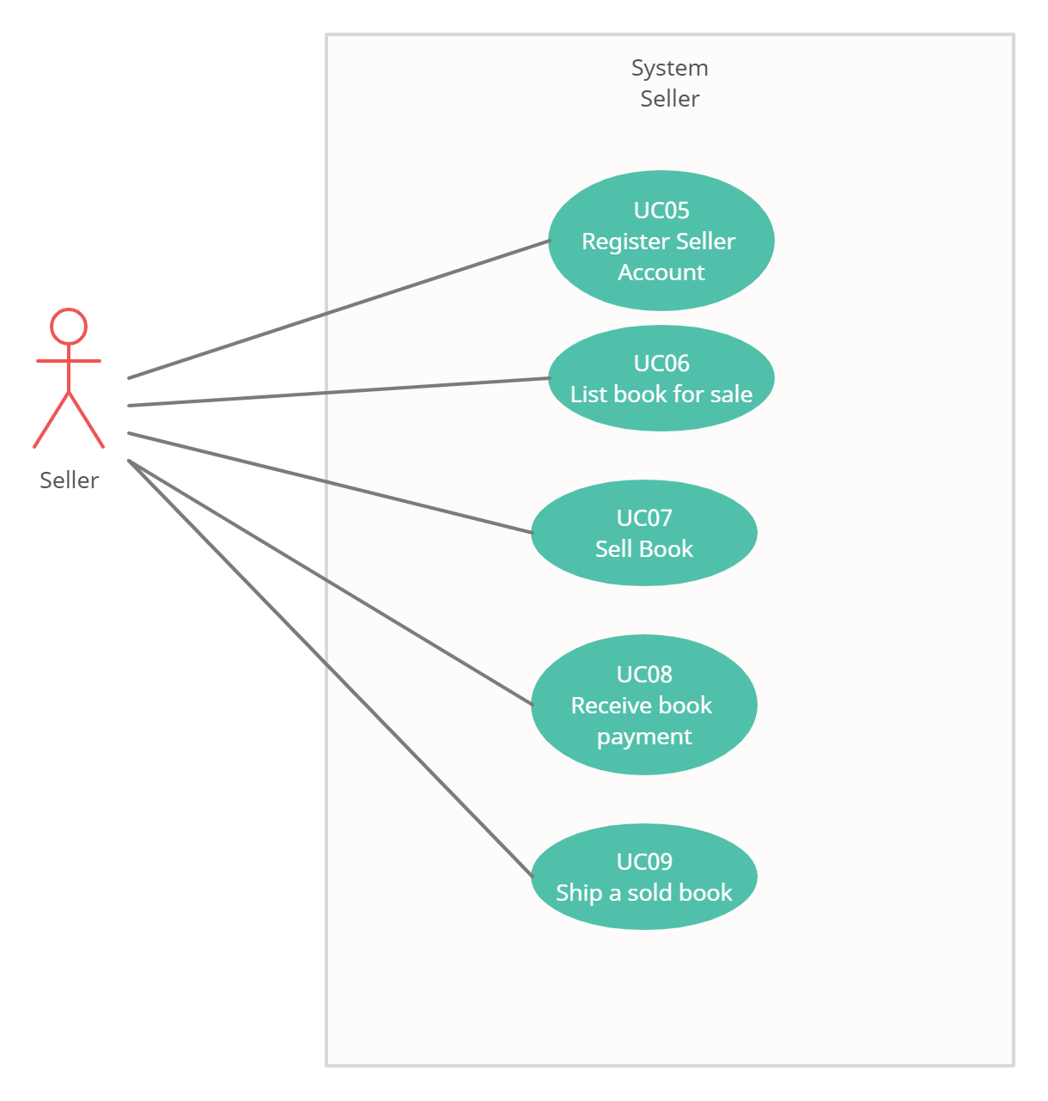

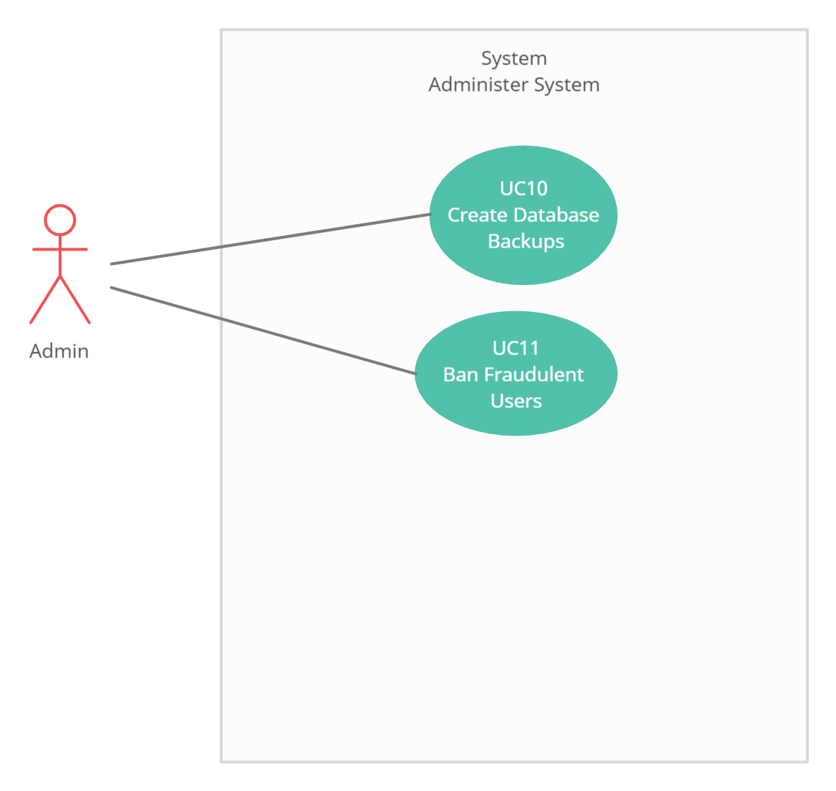

# 10. USE CASE MODELLING

### a. Fully Developed Use Case Description

|  |  |
| --- | --- |
| Use case title: | Buy Books |
| Primary actor: | Buyer |
| Level: | Sea Level / Blue |
| Stakeholders: | Buyer, Seller, PayPal, Payment Gateway, IT Support |
| Precondition: | Buyer is registered  Buyer is logged in  Buyer has at least one book in their cart |
| Minimal guarantee: | Buyer is redirected to the home page |
| Success guarantee: | Book is purchased and the buyers receive a notification saying their purchase has been successful |
| Trigger: | Buyer wants to purchase one or more books |
| Main success scenario:  1. Buyer goes to the book listing page.  2. System displays the book listing page  3. Buyer adds the book to the cart.  4. Buyer selects payment method – credit card or PayPal  5. Buyer is redirected to the appropriate payment gateway to complete their purchase.  6. System sends notification to the book’s seller informing them of the purchase.  7. Buyer waits for notification from seller that the purchase has been accepted. | |
| Extensions:  1a. Purchase page does not respond.  1a.1 Buyer is redirected to the home page.  1a.2 Ask for IT Support online.  4a. Payment gateway is down.  4a.1 Roll back. Session time-out. Redirect buyer to the choosing payment method page.  4a.2 Buyer is instructed to try the purchase later or use a different payment method.  4b. PayPal is down.  4b.1 Roll back. Session time-out. Redirect buyer to the choosing payment method page.  4b.2 Buyer is instructed to try the purchase later or use a different payment method.  6a. Seller does not accept purchase.  4b. Buyer is informed and purchase refunded. | |

### b. Activity Diagram

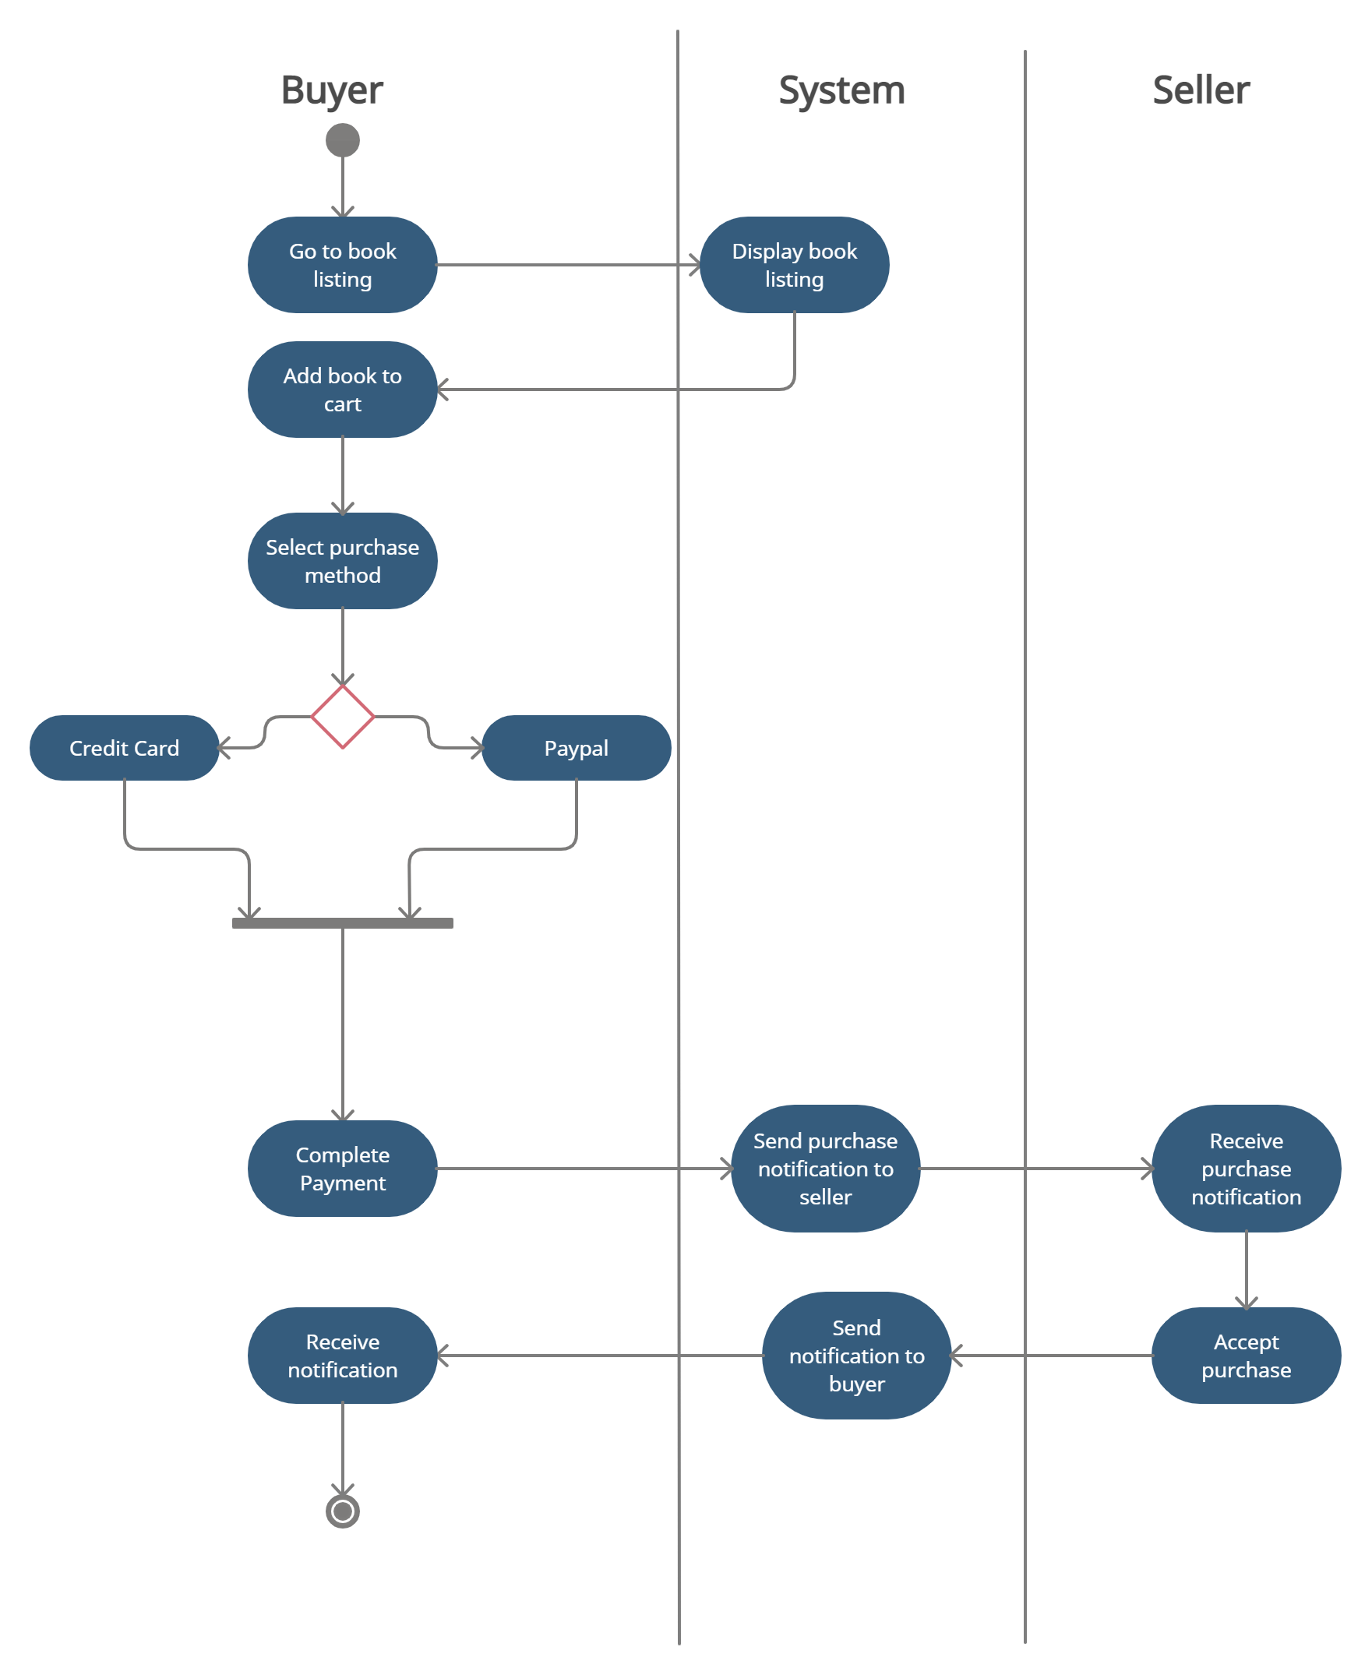

# 11. DOMAIN MODELLING

### a. Domain Classes and Attributes

1. **Classes**  
   Address, User -> [Buyer, Seller], Book, Author, Keyword, BookListing, Order, Invoice, Rating
2. **Attributes**  
   addressID, addressLine, addressType, suburb, postcode, region, country, userID, username, password, firstName, lastName, emailAddress, phoneNumber, creditCardNo, bankingDetails, notificationMethod, bookID, title, category, yearPublished, authorID, authorFirstName, authorLastName, keyword, bookListingID, price, condition, photo, sold, orderID, totalCost, orderDate, orderStatus, invoiceID, paymentType, datePaid, ratingID, score, review

### b. Domain Model Class Diagram

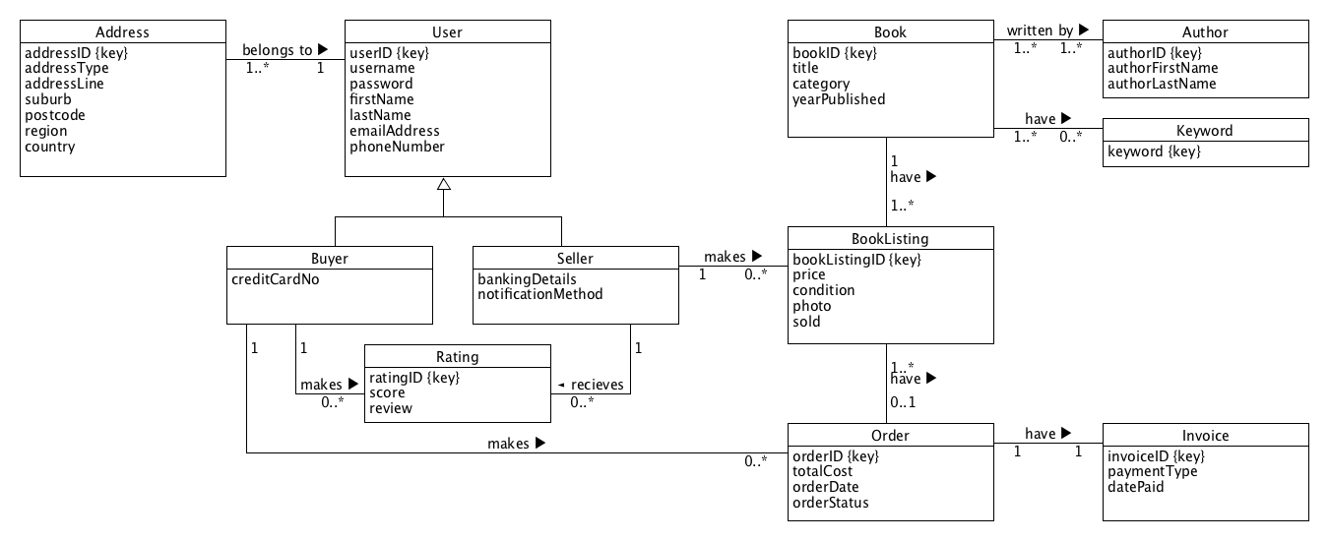

c. Associations

A customer can have one or more addresses.

An address can belong to only one user.

A book can be written by one or more Authors.

An author can write one or more books.

A book can have zero or more keywords.

A keyword can be used in one or more books.

A book can have one or more book listings.

A book listing is made for only one book.

A book listing can have zero or one orders made on it.

An order can be made for one or more books.

An order can have only one invoice.

An invoice can be made for only one order.

A seller can make zero or more book listings.

A book listing can only have one seller.

A buyer can make zero or more orders.

An order can have only one buyer.

A seller can receive zero or more ratings.

A rating can have only one seller.

A buyer can make zero or more ratings.

A rating can be made by only one buyer.